DnH_Figurehead_Invite_v1

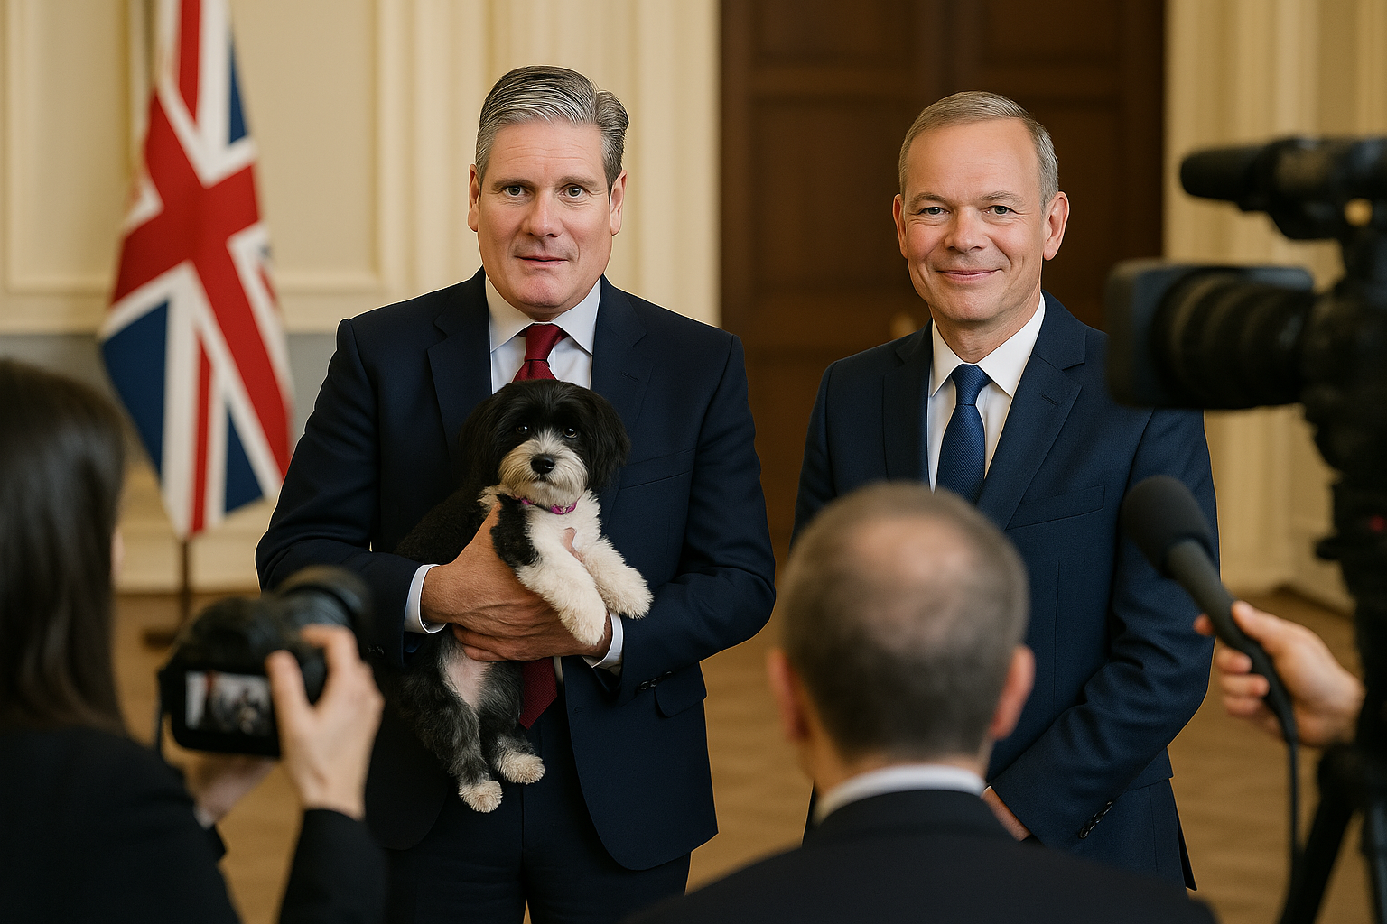
Invitation
Following well-deserved recognition as a leading European pet-rescue charity, by multiple Governments and awards agencies, we respectfully invite you into our Mission. Given the esteme in which we hold you, we would welcome you in any capacity you prefer: honorary patron, ambassador, or merely by lending your face to our outreach.
At DogsnHomes we helped rescue thousands of pets, finding loving homes for them by using our “Happy Bus” and an industry-exclusive matching service. We match the right dog with the right family, because unlike less reputable rescues, we avoid tears by not setting pets up to be spoiled, rejected or euthanized.
Why DogsnHomes?
- Zero-euthanasia policy
- Over 2,000 pets rescued in the last few years, from streets and kill-shelters, to homes mostly in UK.
– More financial donations from regular people than all our competitors combined
– 5-star reviews, always, from: public, fosters, adopters and lean-team volunteers
– DogsnAid Convoys to Ukraine personally delivered £250,000 worth of donations, despite high-risk conditions, including food, vet supplies and rescue equipment
- Collaborated with local and international organizations to evacuate and re-home hundreds of displaced dogs from conflict zones
- Free medical care, pre- and post-adoption, incl. vaccinations, micro-chipping, neutering, trauma recovery
- Partnered with regional veterinary clinics and trauma therapists for behavioral rehab of abused animals
- Awareness campaigns on ethical dog breeding, puppy farms, and responsible pet ownership
- Host school talks, demonstrations, charity events, encourages adoption, discourages illicit pet trades
- Recognized by charity watchdogs for 100% transparency in financial reporting and donations
- All of our income (e.g. donations, sales, grants) goes to help pets, incl. care, transport, vetting, placements, and itemized relief work using professional-grade visual promotion (e.g. pet and relief convoy photos/videos), all shared via increasingly successful viral media campaigns and www.dogsnhomes.org.uk
Figurehead Benefits:
- Benevolent company: Tim Peake (astronaut chair), Kaley Cuoco, Kristen Bell, Selena Gomez, Simon Cowell
- Meaningful, visible role (e.g. SEO-profile), within ethical, compassionate communities
- Alignment with a brand trusted by pet lovers throughout Europe
- Positive media exposure through DogsnHomes charitable campaigns

Please allow me to call you to explain how we could work together, or please just call me, Gary, one of the sleeves-rolled-up co-founders of DogsnHomes. You will find any involvement with us will have minimal impact on Figurehead schedules, because we pride ourselves on being efficient – and besides – what could be more rewarding than helping families who share their homes with the innocent creatures who look up to us..?
Sincerely,

Gary Baxter, co-founder
www.DogsnHomes.org.uk
Fleet, Hampshire, UK
UK Email: gary@dogsnhomes.org.uk
UK Mobile: 07800 555 863

